Exercise 3: Stored Procedures
Scenario 1: The bank needs to process monthly interest for all savings accounts.
Question: Write a stored procedure ProcessMonthlyInterest that calculates and updates the balance of all savings accounts by applying an interest rate of 1% to the current balance.
Script:
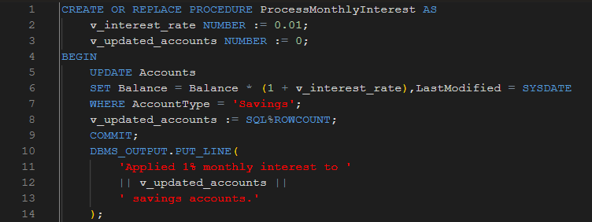
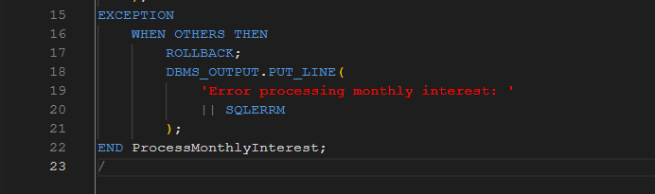
Script Output:
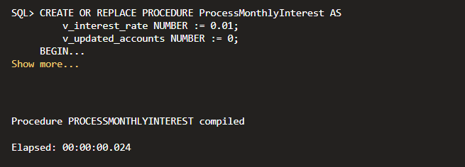

Scenario 2: The bank wants to implement a bonus scheme for employees based on their performance.
Question: Write a stored procedure UpdateEmployeeBonus that updates the salary of employees in a given department by adding a bonus percentage passed as a parameter.
Script:
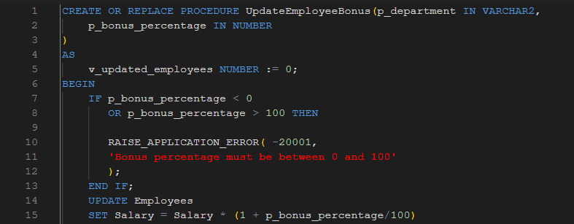
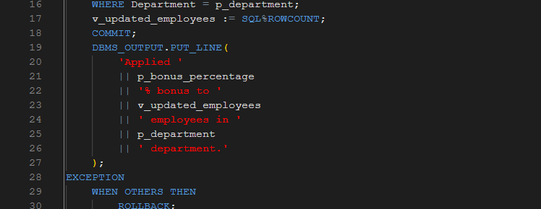
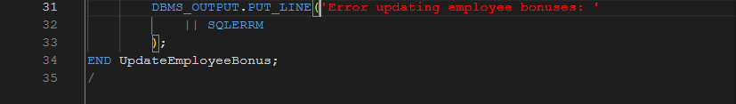
Script Output:
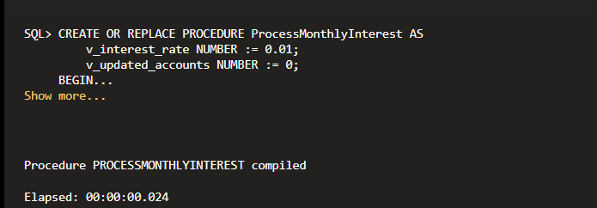
Scenario 3: Customers should be able to transfer funds between their accounts.
Question: Write a stored procedure TransferFunds that transfers a specified amount from one account to another, checking that the source account has sufficient balance before making the transfer.
Script:
CREATE SEQUENCE TransactionSeq
START WITH 100
INCREMENT BY 1
NOCACHE
NOCYCLE;
CREATE OR REPLACE PROCEDURE TransferFunds(
p_from_account_id IN NUMBER,
p_to_account_id IN NUMBER,
p_amount IN NUMBER,
p_result OUT VARCHAR2
)
AS
v_from_balance NUMBER;
v_to_balance NUMBER;
v_from_customer NUMBER;
v_to_customer NUMBER;
BEGIN

IF p_amount <= 0 THEN
p_result :=
'Error: Transfer amount must be positive';
RETURN;
END IF;

BEGIN

SELECT Balance, CustomerID
INTO v_from_balance,
v_from_customer
FROM Accounts
WHERE AccountID =
p_from_account_id
FOR UPDATE;

SELECT Balance, CustomerID
INTO v_to_balance,
v_to_customer
FROM Accounts
WHERE AccountID =
p_to_account_id
FOR UPDATE;

EXCEPTION
WHEN NO_DATA_FOUND THEN
p_result :=
'Error: One or both accounts not found';
ROLLBACK;
RETURN;
END;

IF v_from_balance < p_amount THEN
p_result :=
'Error: Insufficient funds in source account';
ROLLBACK;
RETURN;
END IF;

IF v_from_customer != v_to_customer THEN
p_result :=
'Error: Accounts must belong to the same customer';
ROLLBACK;
RETURN;
END IF;

UPDATE Accounts
SET Balance = Balance - p_amount,
LastModified = SYSDATE
WHERE AccountID = p_from_account_id;

UPDATE Accounts
SET Balance = Balance + p_amount,
LastModified = SYSDATE
WHERE AccountID = p_to_account_id;

INSERT INTO Transactions
VALUES(
TransactionSeq.NEXTVAL,
p_from_account_id,
SYSDATE,
p_amount,
'Transfer Out'
);

INSERT INTO Transactions
VALUES(
TransactionSeq.NEXTVAL,
p_to_account_id,
SYSDATE,
p_amount,
'Transfer In'
);

COMMIT;

p_result :=
'Success: Transfer completed';

DBMS_OUTPUT.PUT_LINE(
'Transferred '
|| p_amount
|| ' from account '
|| p_from_account_id
|| ' to account '
|| p_to_account_id
);

EXCEPTION
WHEN OTHERS THEN
ROLLBACK;
p_result :=
'Error: '
|| SUBSTR(SQLERRM,1,200);
END TransferFunds;
/
Script Output:
Error: Accounts must belong to the same customer

PL/SQL procedure successfully completed.

